

**Submittal Information**

United Pack Nut Assembly

Pack Joint for Copper or Plastic Tubing (CTS)

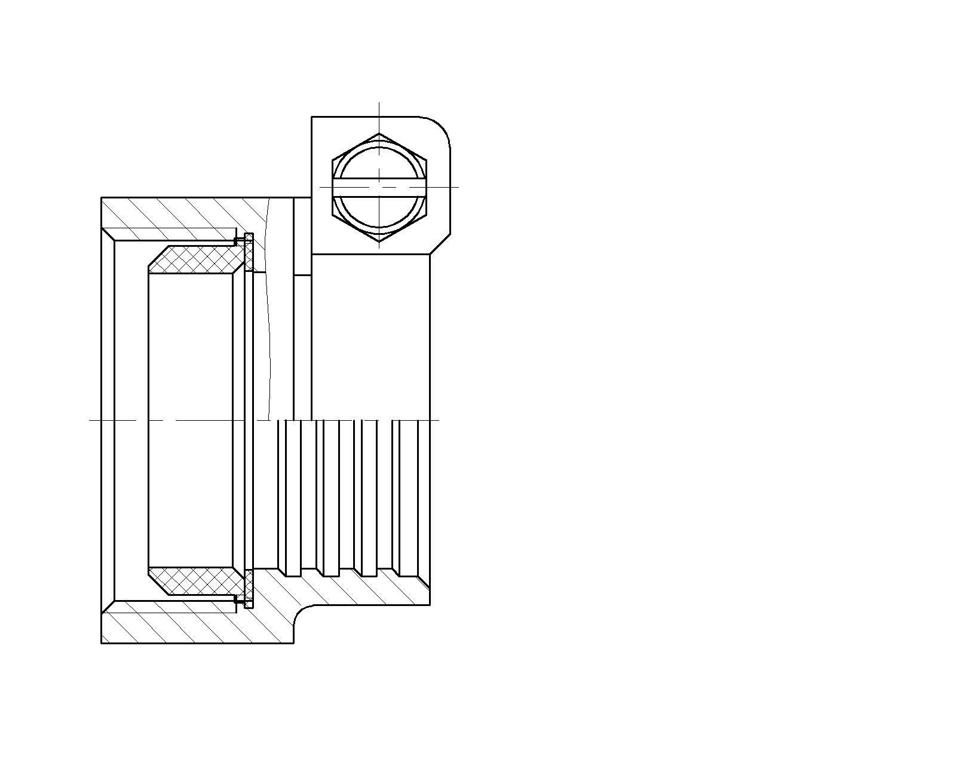

|  |  |  |  |
| --- | --- | --- | --- |
| Connection Size | Weight Lbs. | Length | Part Number |
| ¾” | 0.26 | 1.30” | PACA-3 - NL |
| 1” | 0.32 | 1.28” | PACA-4 - NL |
|  |  |  |  |

**Features**

* All brass parts that come into contact with potable water conforms to AWWA Standard C800 (UNS C89833)
* Components that do not contact potable water conform to AWWA Standard C800 ( ASTM B-62 and ASTM B-584, UNS NO C83600 – 85-5-5-5 )
* Classified to ANSI/NSF 61 and Annex G
* The product has “NL” letters cast into body of fitting for proper identification
* Valve is non-directional and is watertight with flow in either direction
* Ends are integral or secured with adhesive to prevent unintentional disassembly

**Utilities Supply, Inc. 575 Loganville Hwy Winder, GA 30680**

**Website: utilitiessupply.com**

**Email:** [**sales@utilitiessupply.com**](mailto:sales@utilitiessupply.com)